**Service Integration Accountability Model Diagram**   
  
Describes the integration of services involved in a program or group of programs and their accountabilities. Shows the accountability trace from organization unit, service, SLA, output/outcome, target group. It is not a value chain - it does not express how the output is conveyed in the sense of flow of information or material. Rather it expresses who is accountable to whom for providing the output, and the dependencies between the services in order to do so.   
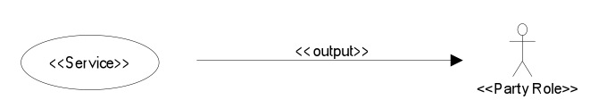   
This is a better example of the form:



Note that org unit, program and output type are identified

UML Package symbol: represents and Organizational Unit accountable for services, contains the services the organization is accountable for.   
  
Ellipse: represents a service that directly or indirectly delivers an output that potentially contributes to the outcome of the program that delivers the service.   
  
Contains the services the organization is accountable for.   
  
Arrow: accountability for service delivery between services – represents the need for or existence of an SLA, OLA or other contract, and performance metrics to define degree of compliance. The source organization unit/services is responsible to deliver the output on the behalf of, but not necessarily to/for the target service/taraget group,  ***Does not imply that the output is delivered or conveyed to the party at the target of the arrow, only that the service is accountable to the party indicated by the arrow***. Indicates the existence of an SLA between the parties. ??This is only between services in MRM, ??How does this relate to output, client set and outcome??

Bearing in mind that we know this part of the Metamodel must be clarified, I think the way to proceed for now is to find every Target Group name related to the Output. In most cases it will be only one or two instances.  
  
Stick Figure: Target Group to upon whom the service output is delivered on behalf of (may not be receiving the output)  ??How is accountability to the Target Group vs. the receiver of the service output distinguished in MRM? Output is connected to target group through client set. There's no connection between the output and an accountable organization. The organization accountable for the Service is accountable for its Output.  
  
?? Should Output be a kind of Class in order to have properties, etc.?? Not sure what you are asking here – please elaborate. Should Output specialize UML Class or DataType in order to capture additional information about the output?  
  
  
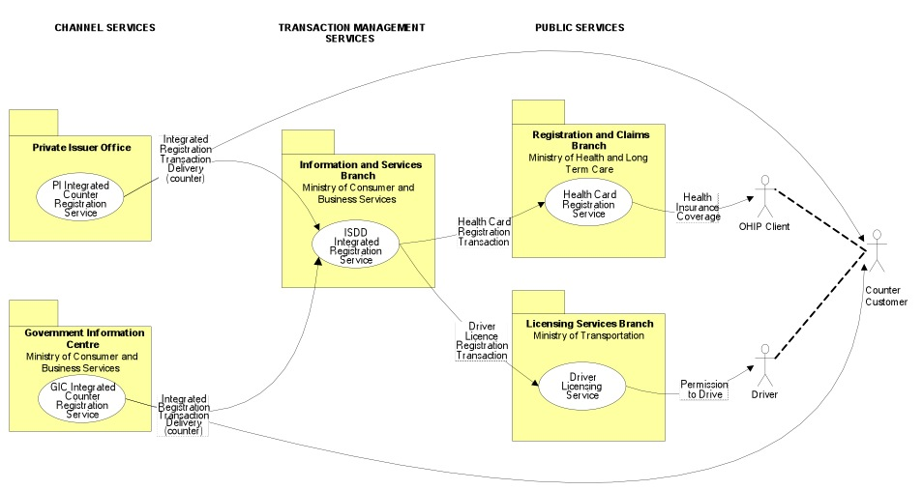  
Questions:

1. The UML package symbol is not a simple icon in SA, it is a custom symbol created by code. Could we use another symbol instead that can be managed as a simple icon? Yes please. The UML package symbol is disliked by executives because it connotes a file. The convention we have used (easy in Visio and Powerpoint) is: square corners=organization; round corners=program; ellipse=service. See example previously.
2. Is it necessary to show an organization unit's accountable services inside the organization unit, or could we consider a more regular "accountability trace" that always uses lines between the involved parties? That is, Organization Unit --Service Accountabilities--> Service --Service Level Agreement--> Service --> Output --Client Set--> Outcome --> Target Group - all nodes connected by edges reflecting metaclasses and relationships in the metamodel? This has not been the convention, and it increases the visual complexity (and size) of the diagram.
3. The lines in SA depict a relationship between metaclasses. The SIAM show the Output of a service on the arrow, but Output isn't a relationship, its a node. Custom code would be required to display the Output on the line instead of the relationship. By default the name of the relationship would appear on the line. I haven’t seen the SIAM conventions used in the PSAM, but I venture to guess they put some effort into conforming with SIAM conventions because of the popularity of the diagram. A key point here is that SIAM diagrams are viewed by all levels of government in Canada, since many services require the involvement of two, three or four levels. See if you can get Charles to send you an example of one.
4. Exactly what metaclasses and relationships should be shown on the diagram and how?:
   * Organization Unit - UML package – preferred: square cornered rectangle
   * Service - UML use case – or an oval
   * Service Accountability - (an accountability line between organization units and services - or position service in organization unit box)
   * SLA between services (an accountability line between services)
   * service Output
   * Client Set (link only)
   * Outcome  - (service output, client set, and outcome are all abstracted in an accountability between the service and the target group - would require custom code. Are the details interesting to MRM?) As discussed, Outcome here should be seen as a link to the Target Group
   * Target Group - UML Actor
   * Program – round cornered rectangle
   * Service Output Type